1. First create a an html,css files, that out put looks like this
2. 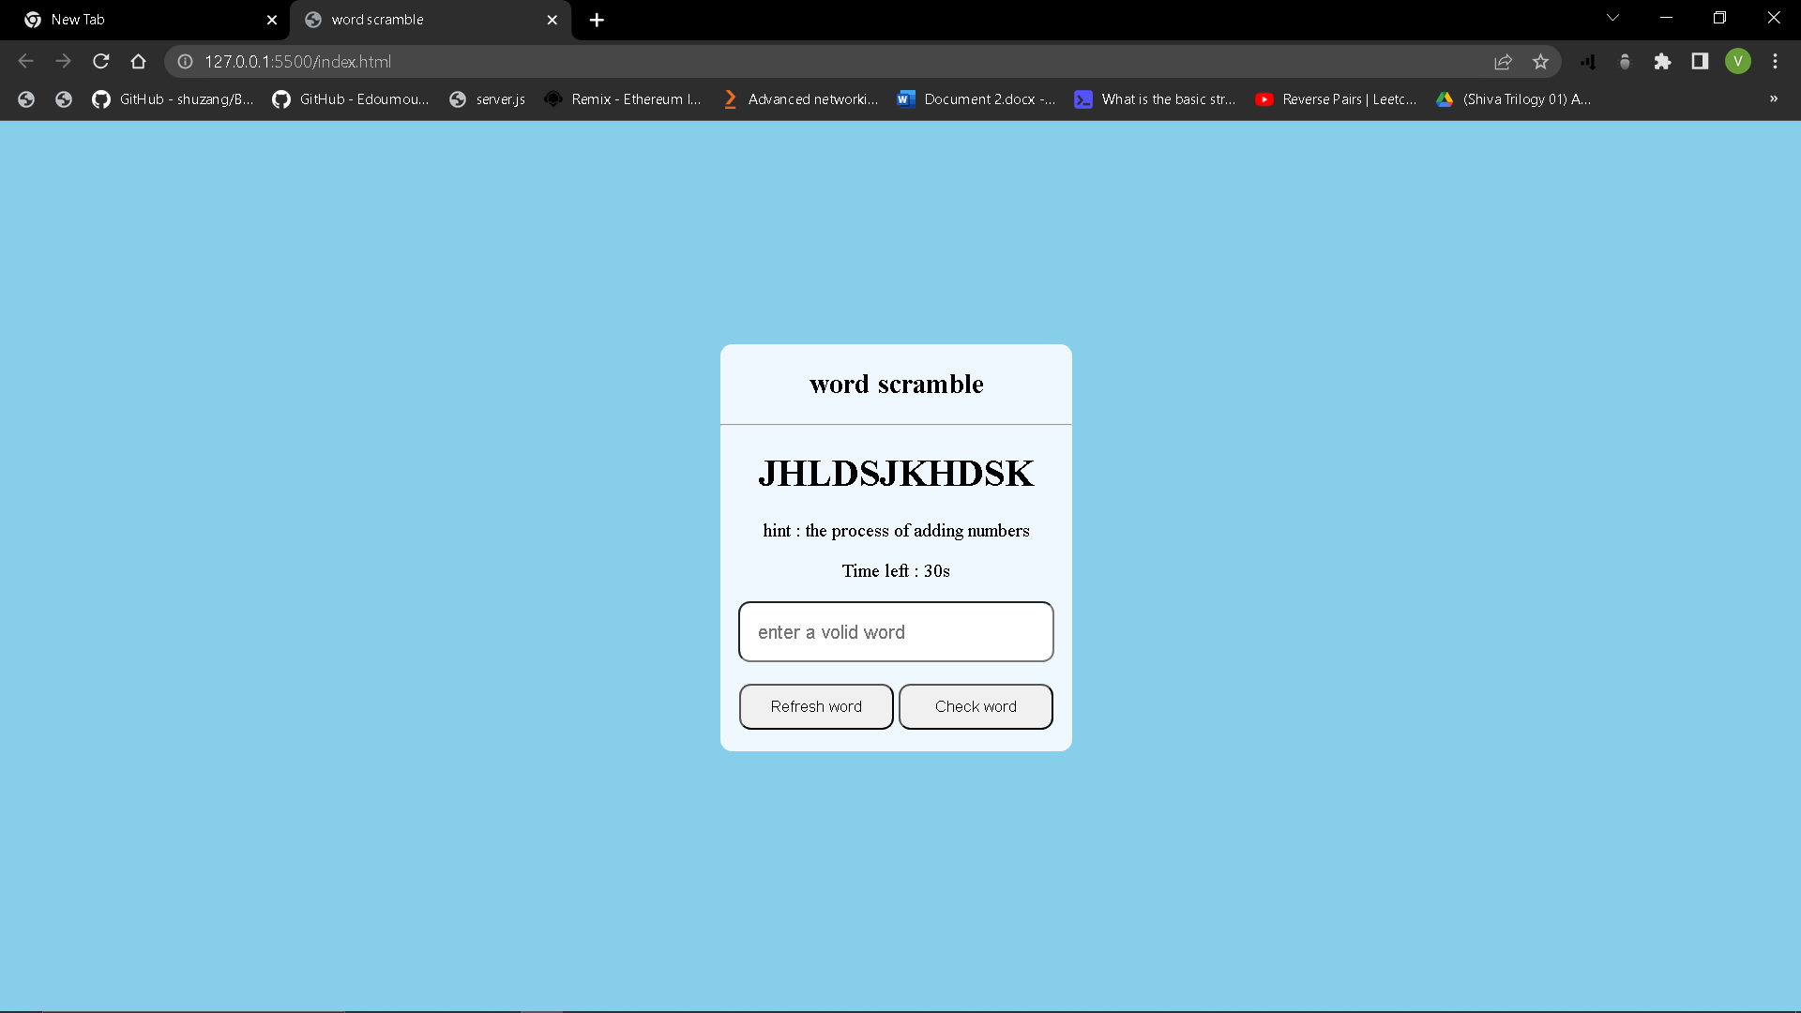
3. If not refer the html and css files which are in github
4. Then next comes is main part, I e javascript
5. Next create an index.js file, import in to html file